**Personal Portfolio Template**

(Group 22)

(Stanislav Berezin aka Stas - n9694315)

(https://github.com/Ericlkl/IFB299-Project)

**Artefact 1** – Logical and Physical Diagram

The artefact represent the technologies that our team has planned to use for the website development. It also includes the deployment infrastructure for our website.

The artefact helps us everyone in the group to get a basic idea of what technologies will be used during development and allows our group to discuss it further. IS students are also able to get a rough idea of what frameworks and technologies are required to create an interactive website. CS students are able to collaborate and discuss further contributions and split the development process between each other.

**Artefact 2** – Software component diagram

This artefact outlines arhitecture of our website and what pages it will include. It also gives a short overview of pages that will be accessing database in production mode.

The artefact helps our team to discuss different design principles and each individual page layout for our website. By using this artefact our team was able to create initial drafts for web design. CS students were capable to finalise the database structure and how it should be implemented. IS students were making many suggestions on different designs and color pallete which helped us to finalise the final design.

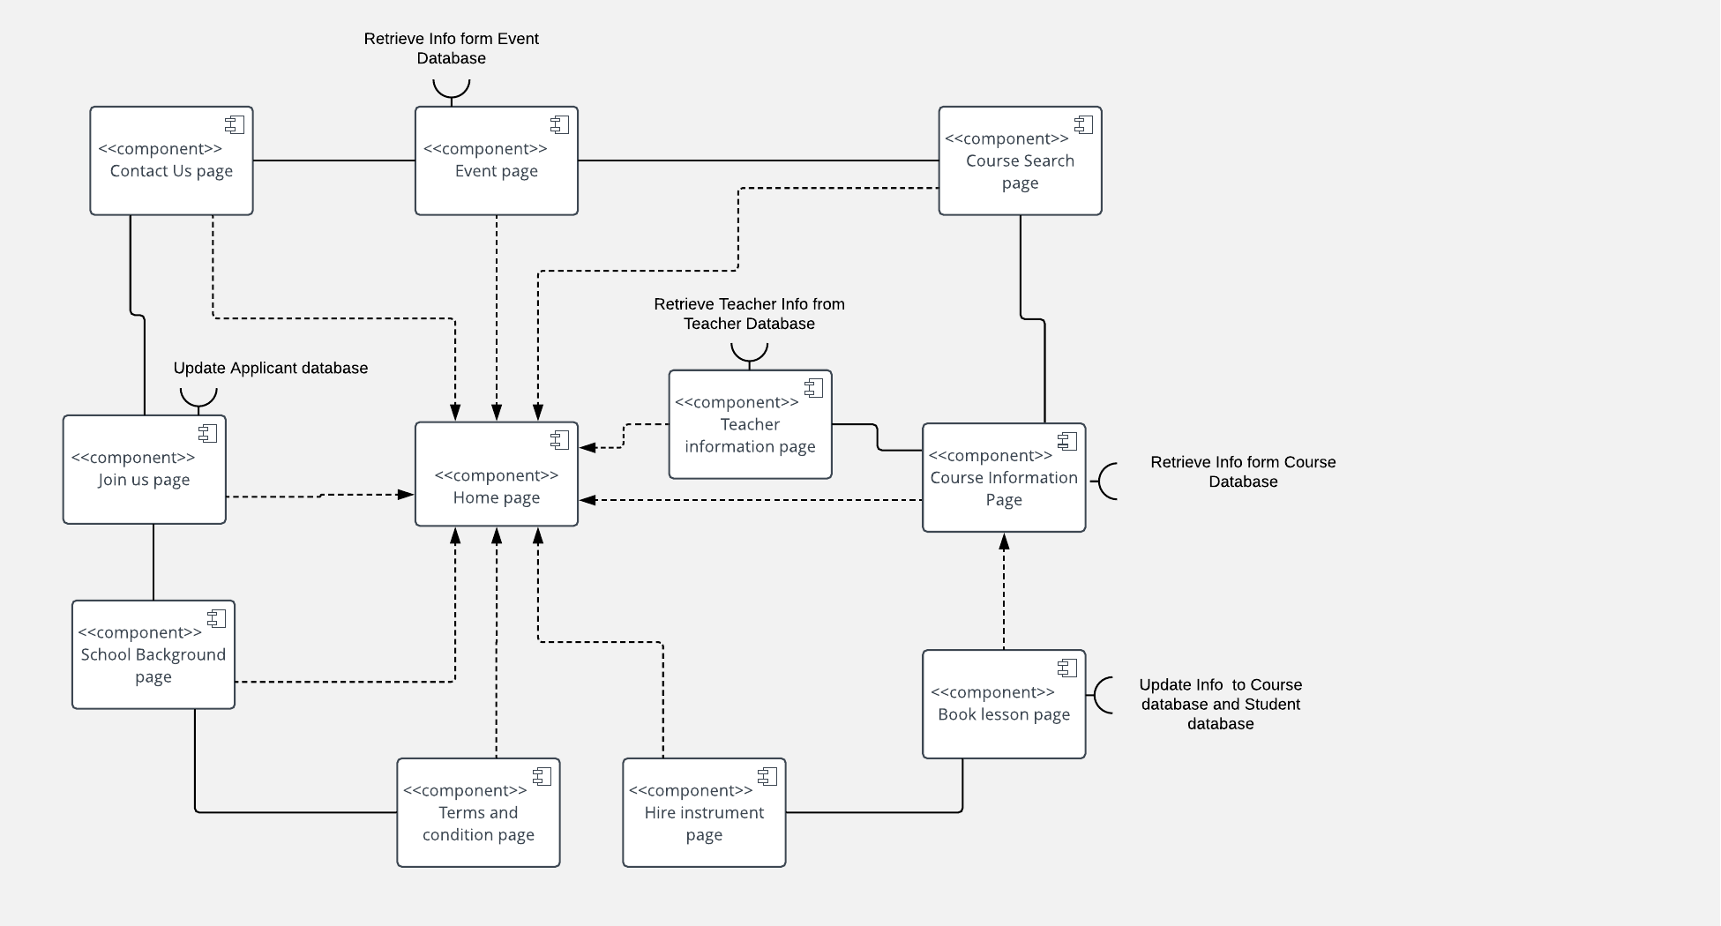

**Artefact 3** – Data flow models

It shows the basic communication of different user models with our website. First, it shows what a student will be capable of doing on our website and what services will be provided to him/her. Second, its shows a process for teacher to apply and become a tutor on our website.

During the development of this artefact it allowed our team to discuss the functionalities that are required for our primarily users (students). Our team was capable to develop ideas for basic functionalities that are needed for our project. CS students were capable of having a straight understanding of what should be implemented for students functionalites from coding perspective.

...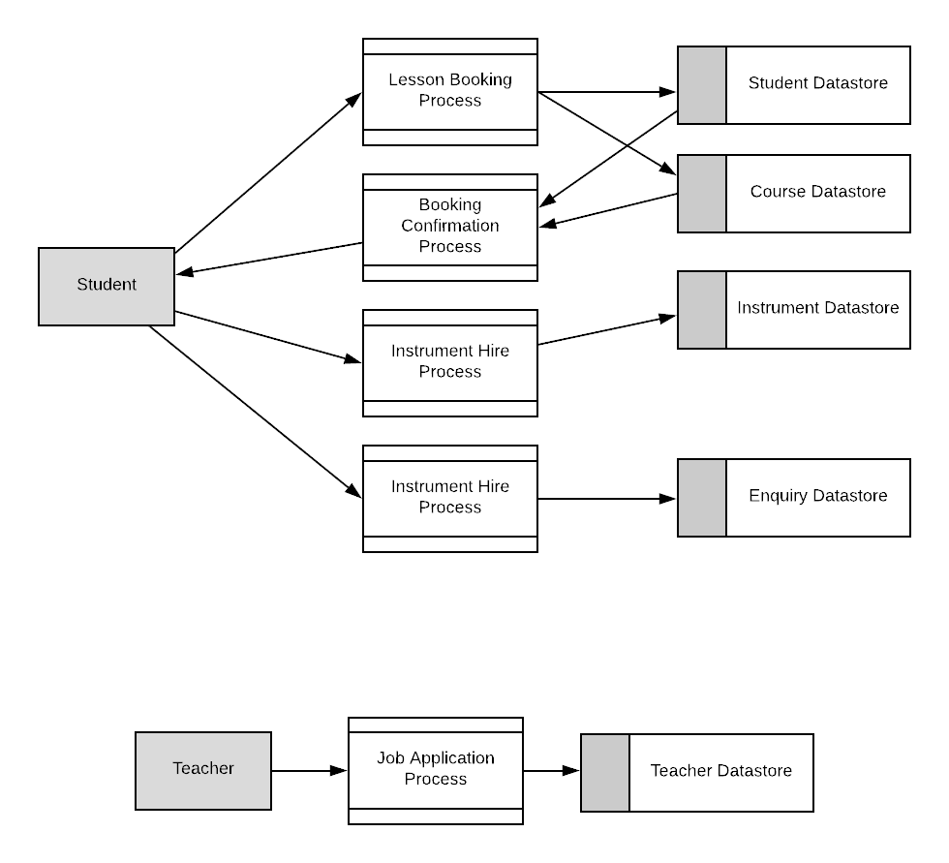

**Artefact 4** – Sprint release 1

Sprint release one outlines all of the things that should be implemented in our first release.

It helped everyone in the team to understand what exactly should be implemented and ordering of those implementations. IS students added the elements that they were capable of doing themselves. Meanwhile CS students assigned story points to the elements that can be finalized only by developers. Overall it gave everyone an idea of what is important for our project and on what elements we should concentrate more.

…

**Artefact 5** – Minute meeting report

This artefact provides an overview of each of our meetings that are done during the workshop and outside workshop hours.

The artefact gives an opportunity to plan our meetings ahead, thus giving an ability to everyone to understand the topics that should be discussed at the meeting. Plus it also gives an opportunity to establish the time-frames under which certain tasks should be implemented. Everyone was able to review these reports just to understand where exactly our team is at and what things we have to do to get the project going

